Apps->workflow
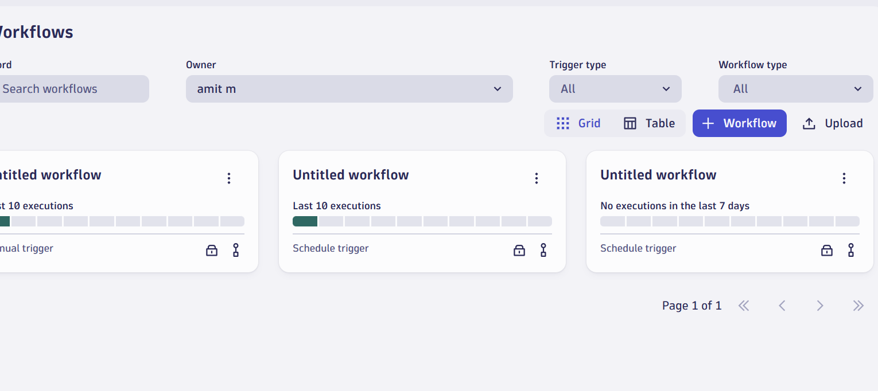

Click on Trigger

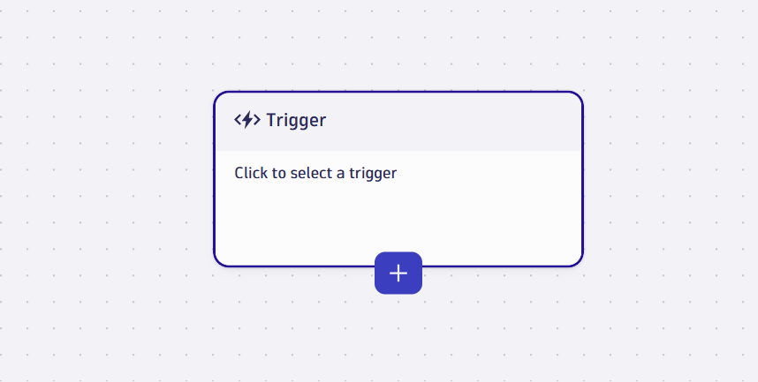

Select cron Schedule

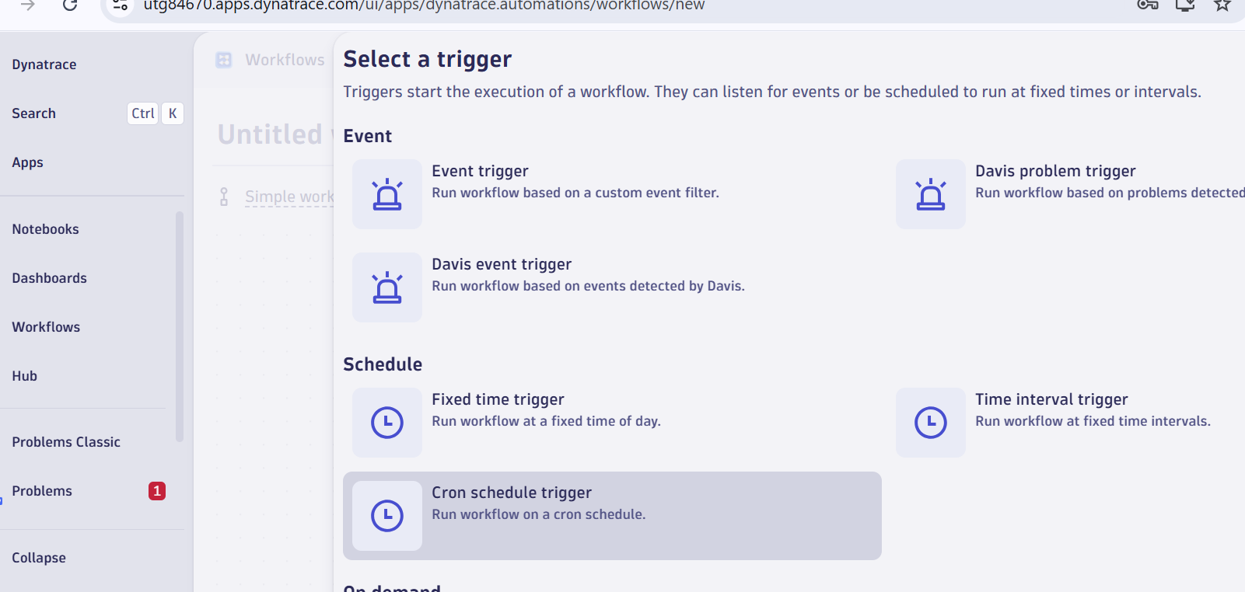

New task
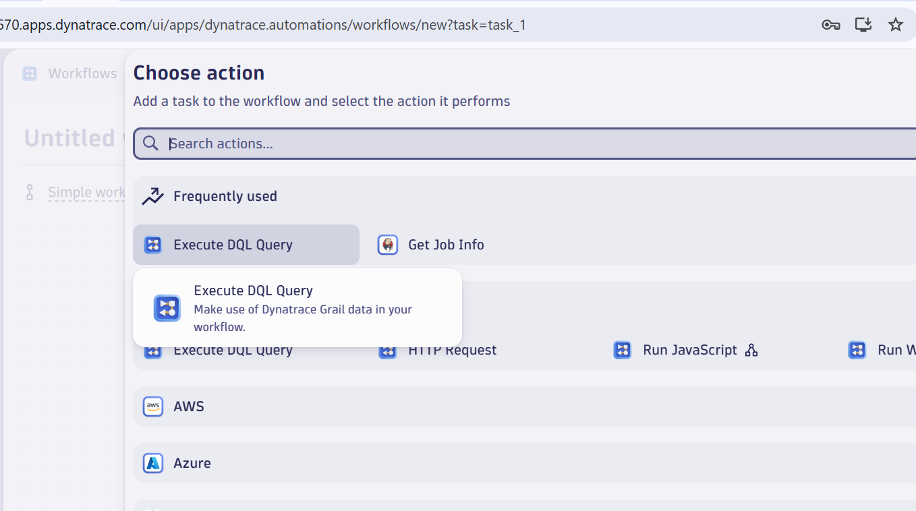

Copy this query

fetch logs
| filter NOT matchesValue(status, "WARN")
| makeTimeseries count = count()
| limit 20

